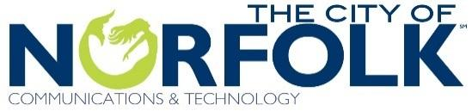

**Open Data Liaison Meeting**

**May 4, 10a to noon**

**Agenda**

10a to 10:15 **Welcome & Introductions** Steven DeBerry; Norfolk CIO

10:15a to 10:30 **Introduction to Open Data** Katya Abazajian; the Sunlight Foundation

10:30a to 10:45 **Open Data in Norfolk** Pamela Marino; ComTech Management Services Administrator

* + - * Open Data Program
      * Open Data WorkFlow
      * Open Data Policy Review

10:45a to 11 **Role of the Data Liaison** Fraser Picard; ComTech Assistant Director

11a to 11:15 **Beginning** **Data Inventory** Kyle Spencer; ComTech GIS Team Supervisor

* + - * Template and Submission Rules
      * Use of NEL Workers

11:15a to 11:30 **Meeting Wrap Up** Pamela Marino

* + - * Next steps
      * Next meeting



**FAQs**

What are the duties of the Departmental Data Liaison?

1. Serve as the “go-to” person for information about data your department keeps as well as the format in which the data is saved.
2. Attend the initial citywide data retreat:
   1. Discuss the data that each department keeps and potential restrictions regarding releasing some data
   2. Brainstorm ways to share data and ensure it is continually updated
   3. Keep your supervisor/department head informed
3. Commit to attending other meetings or telephone conferences

Who was chosen to be a Departmental Data Liaison?

1. Staff members who are very familiar with the data that is saved by your department and understands the format in which the data is saved.
2. Staff members who are responsive and responsible and interested in helping the city do a better job of making data-driven decisions and engaging citizens.

**For more information about the What Works Cities initiative, visit the ComTech webpage at** [**www.norfolk.gov/index.aspx?NID=1686**](http://www.norfolk.gov/index.aspx?NID=1686)